
Register in MyPassword
The University of Tasmania is improving security and access by introducing MyPassword, a self-service password reset portal.
All Students, Alumni and Staff will need to register to the service, which will bring the University 's security policy in line with other tertiary and government organizations.

Acknowledgement:
Special thanks to student Ms. Xia Mengjiao from IS cohort 2013 who has drafted this instruction manual.

- Open a web browser and type in the UTAS Mylo URL
http://www.utas.edu.au/mylo
- Find ‘MyPassword’ then click it
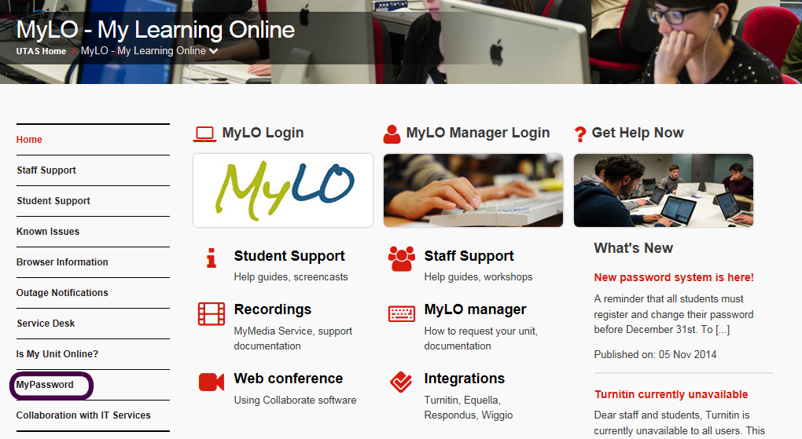

- Before clicking ‘MyPassword Register’,read ‘Password Rules’ carefully
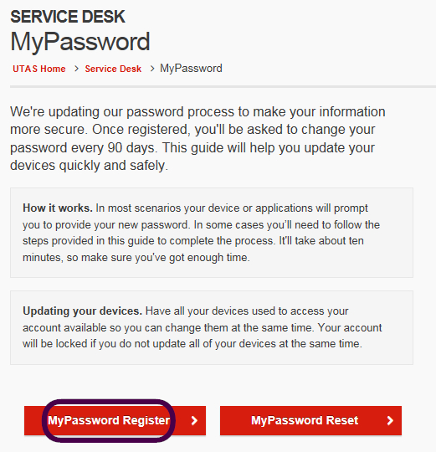
- 你的密码必须由8位或8位以上字符组成，其中需要包括至少一个大写字母，一个小写字母和一个数字
- 密码必须每90天更改一次（新密码要在使用一天之后才能再次更改）
- 新密码不能与旧8位密码相同或相似
- 密码不能是你的姓名以及任何未做改变的字典单词
- 新密码更改之后，请在你常用登陆（保存过旧密码）的设备更新你的密码，如果多次登陆失败，你的账户会被系统锁定15分钟
- 必须于2014年12月30日之前完成注册，否则澳方更新网站之后账户将无法使用
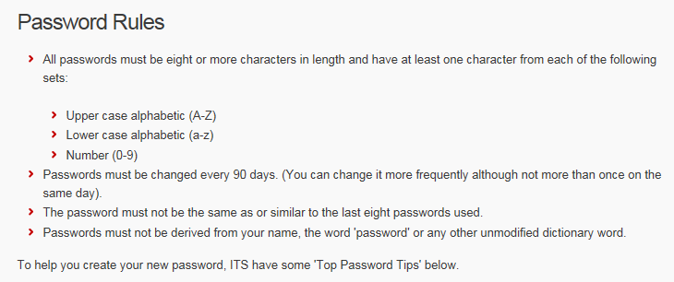
- Enter your username and existing password
Click ‘Login’ to begin the registration process
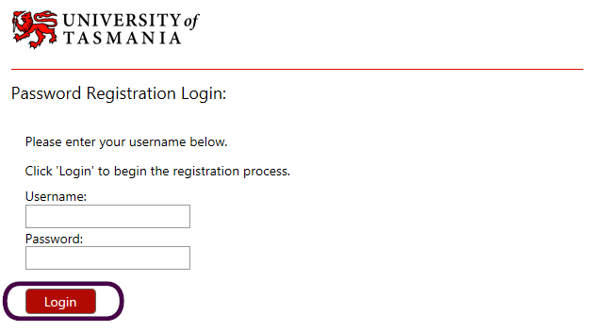
- Click ‘Next’
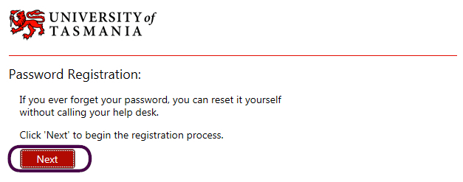
- Choose to answer at least 6 questions
Each answer must contain at least 3 characters, and no 2 answers may be the same
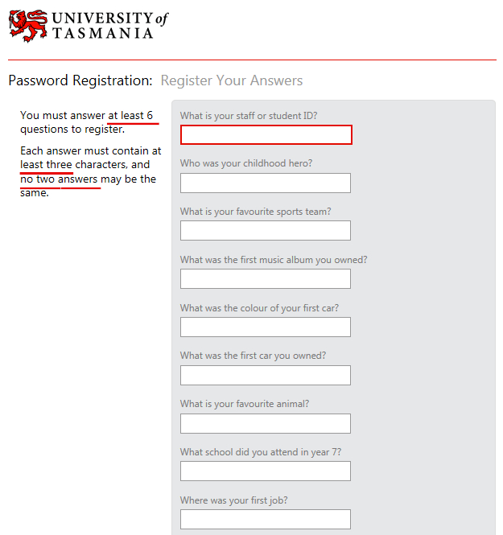

- Please write down the questions that you have chosen and their corresponding answers on your notebook and remember to take good care of it
After that, click ‘Next’

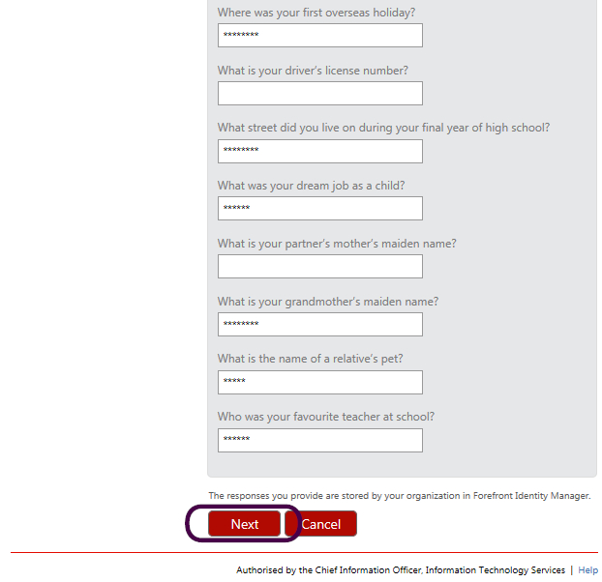

- Click ‘Go to the reset password portal’

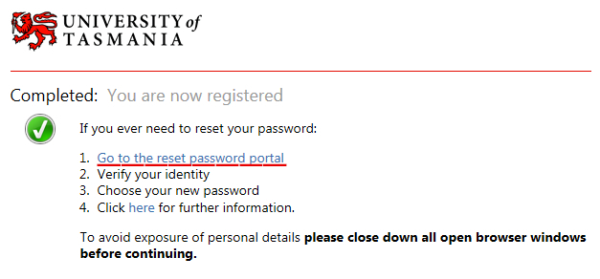
- Enter your username then click ‘Next’
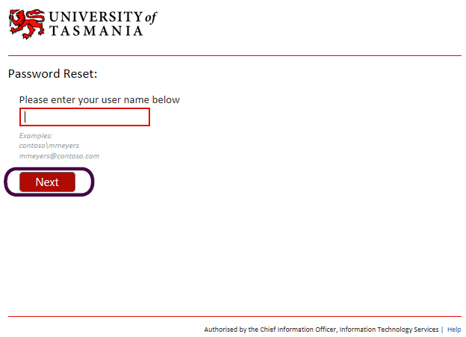

- Answer the 3 questions which you chose before and
then click ‘Next’
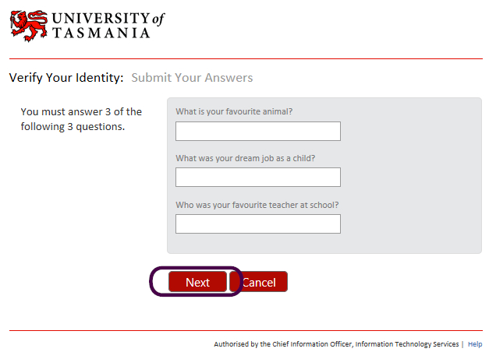
- If your answers are right, you will be directed to this page
Enter your new password and re-enter it then click ‘Next’
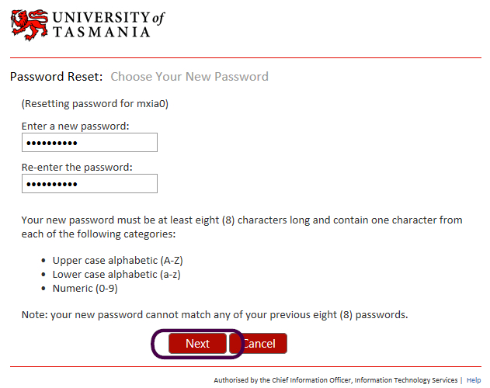

- After your password has been reset, please update your password.

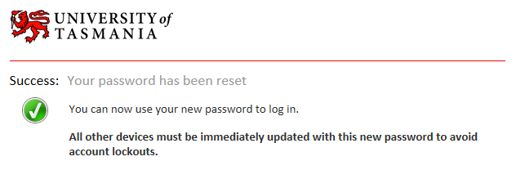

What if a problem?
Help!
service.desk@utas.edu.au (Remember to use your webmail account otherwise your email might be identified as trash email.)

Or: Please approach the T&L Admin office, Room 202, AIEN Building for advices.

